MEMORANDUM

To: Dr. Sun, Manager
From: Kat Davis, Consultant
Meahgan Pear, Consultant
Date: November 6, 2007
Subject: Analytical Report for the Pokagon Band of Potawatomi web site

INTRODUCTION

The Pokagon Band is a specific set of Potawatomi Native Americans that runs as a separate government entity from the United States of America. However, even as a government organization the Pokagon Band of Potawatomi Indians struggles to maintain an effective web site for the tribe, partially due to the lack of funding and educated staff to create and maintain a well designed and functional web site.

The majority of tribal documents and information are available on the current Pokagon Band web site, but the content organization and design of the web site are quite basic and could be more functional to better suit the tribal members’ needs. As of now, there is a vast amount of room for improvement and development on their web site, specifically in the realm of content management.

The Pokagon Band web site could benefit from valuable recommendations in terms of content management, organization, and overall appearance. Detailed research was conducted on their web site through three primary methods to establish a recommendation report for the information architecture of the Pokagon Band of Potawatomi web site.

OBJECTIVES

In developing recommendations for the content management and information architecture of the Pokagon Band web site the following objectives were set.

- Determine how useful the web site is to the primary and secondary user groups
- Determine if a different method of organization/categorization will better facilitate comprehension of the web site by the user groups
- Provide detailed recommendations that will help the Pokagon Band with useful and efficient information to improve their web site

METHOD

In order to effectively make content reuse recommendations for the Pokagon web site three primary research methods were used to compile sufficient information.

- Genre Analysis
- User Interface Design Analysis
- User Workflow Diagram

Furthermore, a brief Content Analysis and an interview with the Network Manger for the Pokagon web site were conducted to further our understanding of the Pokagon Band web site.

Genre Analysis
This method was used to better understand the construction and purpose of the Pokagon Band web site by comparing and contrasting it with similar genres – Native American web sites. This analysis was also conducted from the readers’ perspective, rather than the users. In completing this Genre Analysis the following information pertaining to the Pokagon web site, as well as similar web sites, was obtained:

- Writers and developers
- Audiences and users
- Format and organization
- Level of formality
- Use of visual cues and images

Overall five Native American web sites were analyzed, and in order to stay close to the target audience only Potawatomi web sites were analyzed. The following web sites served as the basis for the Genre Analysis:

- Citizen Potawatomi Nation http://www.potawatomi.org
- Forest County Potawatomi http://www.fcpotawatomi.com
- Nottawaseppi Huron Band of Potawatomi http://www.nhbpi.com
- Prairie Band Potawatomi Nation http://www.pbpindiantribe.com
- Match-E-Be-Nash-She-Wish Band of Potawatomi http://www.mbpi.org/

User Interface Design Analysis
With the User Interface Design a more thorough analysis of the Pokagon Band of Potawatomi web site was conducted. This method analyzed the Pokagon Band web site from the users’ perspective. Detailed user-cases and personas were created to provide a basis for each group that uses the Pokagon Band web site. Each of the user-cases details a specific fictional individual, which represents the larger user group. This is done to create a more detailed and specific understanding of how the user groups use the web site.

Also, different views and objects were complied based on each user groups. The views are primarily what a specific user groups sees upon looking at the web site. For example; when a tribal council member looks at the homepage, he might view only the information pertaining to tribal documents or government documents. However, if a member from the general public (a non-Native American) were to look at the homepage of the web site, she might view the sections of information pertaining to the history of the tribe. In addition to the analysis of the various user views, web objects were also analyzed on how they were used and which user group they were used by specifically.

User Workflow Diagram
A User Workflow Diagram was used to help further the research and illustrate the workflow of the Pokagon Band web site. A User Workflow Diagram is a grid based chart that depicts specific users and their tasks. On the diagram dots are made to match a user with a task. This diagram helped pinpoint multiple users that performed the same task and multiple tasks that were performed by one user. We used a User Workflow Diagram to analyze the Pokagon Band web site and track two primary user groups: the tribal members (including tribal council) and the general public (including Native Americans from other tribes and non-Native Americans).

RESULTS & DISCUSSION

Genre Analysis
By looking at these different sites we were able to get a good sense of how other Potawatomi bands are providing their tribal members and the public with information about the tribe. Some of the different things, in terms of design and layout that we found on a lot of the sites are as follows:

- All of the sites had clear and easy navigation
- Most of the sites had a contact page
  - Even with the contact page there was limited contact information – only one or two e-mails on most of the Web sites
- Most of the sites had the following sections or navigation links
  - Human Resources
  - Links
  - Education
  - Social Services
  - Gaming Commission
  - History
- All of the sites had a page devoted to Tribal Council or Tribal Government
- Most of the sites had a schedule of upcoming events
- Most of the sites had a tribal motif, including traditional pictures from their specific band
- Most of the sites had graphics and text
  - Some sites had interactive graphics and made use of Flash
- All of the sties had their tribal emblem visible throughout the site

The complete Genre Analysis can be found in Appendix A.

User Interface Design Analysis
Our results of the User Interface Design Analysis indicate that there is a lack of information for the general public (non-Native Americans) on the Pokagon Band web site. Information is easily available and accessible to the other user groups.

The Tribal Council/Administration uses the web site to post information for the other user groups to view. General members view, download, and print off the information available on the web site. Other bands of Potawatomi Indians use the site to compare tribal documents or to use the Pokagon Band’s information as a model for improving their documents. The general public (non-Native Americans), use the site to gain information about the Pokagon Band.

The complete User Interface Design Analysis can be found in Appendix B.

User Workflow Diagram
We used the personas created from the User Interface Design Analysis and studied the user workflow. Each user group is represented and the task and content each of these user groups utilizes on the web site are also represented. Figure 1 is a graphical representation of our findings.

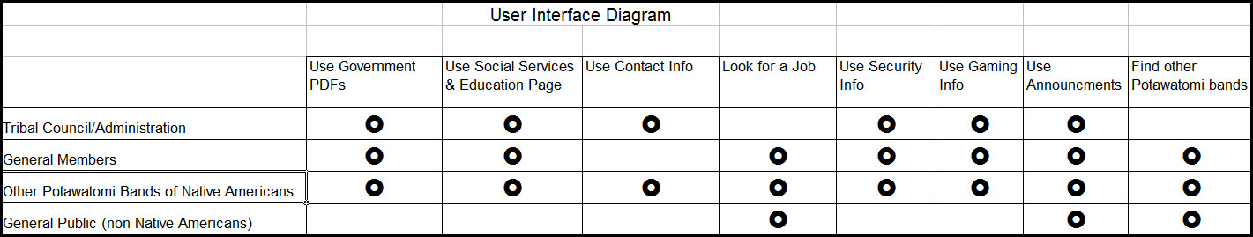
Figure 1

Content Analysis
In analyzing the content we found that most of the current content consists of downloadable PDF files. The majority of these PDF files are tribal documents dealing with Governmental Documents, Educational Documents, Employment Applications, and Gaming Commission Documents. The PDF files are used primarily by tribal members, both the general members and the tribal council. There is very little body text on the web site and not many graphics or illustrations. In terms of content reuse there is not much room for content reuse, especially the content from the Gaming Commission and the Department of Education page. The only content with the possibility of reuse at this point are the mission statement and general tribal history.

Personal Interview
After speaking with Robert Willis, the Network Manager of the Pokagon Band web site, we learned that the Pokagon Band of Potawatomi are currently working on their web site and are in the process of purchasing a Content Management System. We also gained knowledge to help us with the user-cases completed in the User Interface Design Analysis.

CONCLUSION

It is clear that the Pokagon Band of Potawatomi web site is in need of solid recommendations in terms of organization/categorization and content management in order to better facilitate the comprehension of the web site by its various user groups. Through the various research methods (Genre Analysis, User Interface Design, and User Workflow Diagram) the results show that the Pokagon Band web site is currently an amateur web site that could benefit from a restructuring of all the content, and specifically from valuable recommendations in terms of content management, organization, and overall appearance.

APPENDIX A: COMPLETE GENRE ANALYSIS

Writers and Developers
It is clear that the main author of the web site is the Pokagon Band of Potawatomi Indians as a whole. Since this Native American tribe is considered a government organization there is material on the web site that pertains to all members that is written and developed by the administration of the tribe (tribal council). Even though the majority of the content is written by the tribal council or administration, specifically the downloaded documents, Robert Willis, the Network Manager is web master and the primary content manager. Willis is also primarily responsible for the web site’s content and design. On the Pokagon Band web site there is no information linking Willis as the manager of the web site. He and the rest of the authors are “invisible,” meaning there is no mention of the author’s names on the page. Instead, each of the web pages contains a copyright to the Pokagon Band of Potawatomi Indians as an organization and as the primary author of the web site.

Even though the authors and production team are invisible, the web site does house clear information that cues the readers in to the organization’s identity, purpose, and mission. First there is the Pokagon Band Tribal Emblem which tells the readers that they are on an official Native American tribal site, and specifically the Pokagon Band. Second, there is the statement of recognition, which states that the Pokagon Band is a federally recognized tribe instated by President Clinton in 1994. Lastly, the background of the web site contains graphics that are clearly representative of the Native American culture. All of these elements also provide the reader with an element of credibility, especially the copyright notice at the bottom of all the web pages and the official recognition statement by President Clinton.

In addition to the elements that cue the reader into the organization’s identity, the overall site design and organization also helps the reader know they are on a Native American tribal web site. Although this may be a generalization, the overall feel of this web site has an amateur tone. A lot, but certainly not all, of Native American web sites are not professionally designed (although a few of the web site analyzed in the genre analysis were). Also, the Pokagon Band web site is consistent with the feel of most Native American web sites because it shows the pride the tribe has in their heritage through the use of Native American graphics, illustrations, and photographs.
.
Audience and Users
Looking at the research obtained form the genre analysis, primary and secondary users groups were established. The primary user group consists of the Pokagon tribal members. The primary user group was then broken down even further into both tribal members and tribal council, both of which consist of tribal members living on and off the reservation. The secondary user group consists of the general public, which includes the sub categorizations of potential members, other Native American bands, and non-Native Americans.

With these two main user groups (tribal members and the general public) there are links and paths present on the web site that are meant to appeal to these specific groups. Most of the links (education, social services, gaming commission, tribal government, etc.) are geared toward the primary users. Secondary users can use them if they know what they are looking for, especially if they are researching the tribe, but for the most part the majority of the web links and paths are meant to be utilized by the primary users group – tribal members. Since this web site is primarily geared toward tribal members, most individuals from this user group will be utilized the web site as a standard of reference. Members will more than likely search the web site for information, print out tribal documents, and bookmark the page to check for tribal updates and contact information.

Format and Organization
The Pokagon Band web site is somewhat similar to other Native American tribal web sites since almost all of the web sites in this genre have the following elements: they all have a tribal emblem present, a human resources page, and gaming commission page, a tribal council/government page, a links page, and a brief tribal history. The only thing that predominately separates the Pokagon Band from others in this genre is the fact that the Pokagon web site is geared significantly more toward tribal members, whereas a lot of the other Potawatomi web sites are geared toward the general public, especially in providing more historical background and information about the tribe. The Pokagon Web site seems to provide more insider information and documents that would only be of use to the tribal members.

Level of Formality in This Genre
As stated above, the Pokagon Band web site has a very amateur tone to it. In fact the overall web site is not very formal and it shows the lack of web knowledge both in content and design. However, the Pokagon Band has two major set backs: lack of money and qualified people to produce a good site. Thus, the level of formality needs to remain fairly simple, at least enough so the non-educated and inexperienced web users can easily navigate the site.

Use of Visual Cues and Images
All of the links are clearly displayed and labeled at the top of the page in a horizontal navigation bar. This makes it easy for the users to identify the type of information they are looking for and find the correct page to click on. Moving down into the body content there is not much variation used in the text. However, on some of the pages, such as the education page, there are bold headlines done in reverse font which separate them from the rest of the text. However, the format of headlines and subhead is not consistent throughout the entire web site, which throws the reader off and makes the overall navigation confusing. The text on the homepage is centered, which makes it very hard to read. On the rest of the pages most of the body copy is left aligned, but the headlines are centered. This alignment is too inconsistent and confusing. Although all the text is in a one-column format it is still confusing with the various alignments. There is also very little visual representations. The main visual representations are the logo and background. With the information the visual representation extends to the links and the PDF files of all the documents that can be found on the different pages.

APPENDIX B: COMPLETE USER INTERFACE DESIGN ANALYSIS

User Cases
Before divulging into detailed results, user cases were developed first in order to thoroughly understand the intentions of each user group. The two main user groups and their respective user cases are as follows:

Tribal Members

Tribal Council/Administration: Lucy Waterchild
Lucy Waterchild is the secretary for John Turner, a Tribal Councilman. John has asked her to distribute next week’s council meeting’s agenda. After discussion options with John, they agree to post it to their website so any one who is interested in the topics can attend.

General Member: Jim Buffalo
Jim Buffalo works on the reservation. He’s married with two children. After work he loves spending time with his children, but he also feels it’s his duty to participate in tribal affairs. Tomorrow is a tribal council meeting and he’s not sure if there is a reason to attend. Jim goes to the Pokagon band’s website and finds the council’s agenda under “Tribal Government”. He downloads the PDF and sees no topics of interest for that meeting. He decides to take his son out for a walk that night to talk with him about his childhood.

The General Public

Member of another Potawatomi Band of Native Americans: George Huron
George Huron is a 24 year-old construction worker and a member of Nottawaseppi Huron Band of Potawatomi. One day while surfing the Internet he becomes curious about other bands of Potawatomi. He remembers the Pokagon Band is part of the Potawatomi and searches for them through Google. He finds their site and compares tribal information. After he’s looked through every link, he moves on and does something else on the Internet.

Non-Native American: Janessa Donaldson
Janessa Donaldson is a senior psychology major at Western Michigan University. She recently found out her friend, Eliza is a member of the Pokagon band of Potawatomi Indians and wants to learn more about her friend’s heritage. She searches “Pokagon band Potawatomi Indians” in Google and is lead to www.pokagon.com. She clicks around the links, but finds nothing of interest, except the home page. The “Announcements” link seems promising, but it leads her nowhere. Eventually she leaves the site through a link on the “Links” page.

Views
In order to further understand what each user group is utilizing the Pokagon Band web site for, different view were analyzed. The results and research are as follows for each user group:

Tribal Council/Administration. The task analysis indicated that tribal council/administration members post objects (web material) on the web site for all user groups to view. These views are the following pages: Department of Education, Department of Human Resources, Department of Social Services, Tribal Government, Gaming Commission, and Tribal Police. Screen shots of two of these views can be seen in Figure 1 and Figure 2.

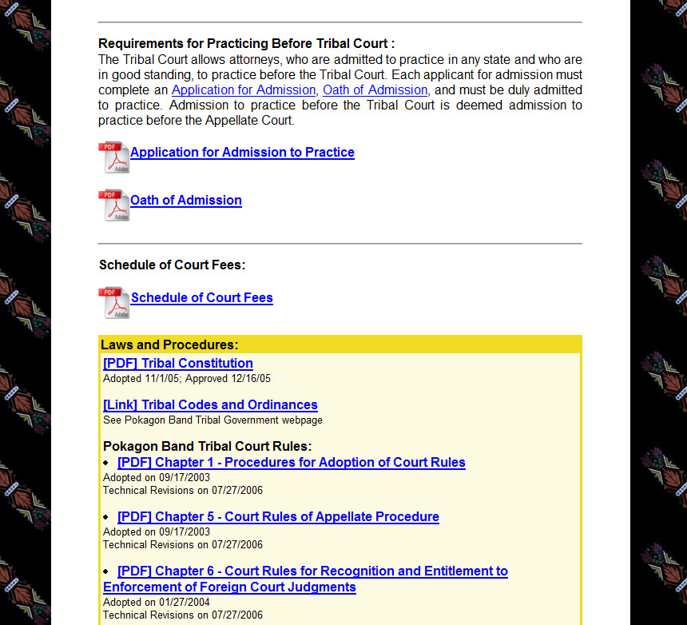
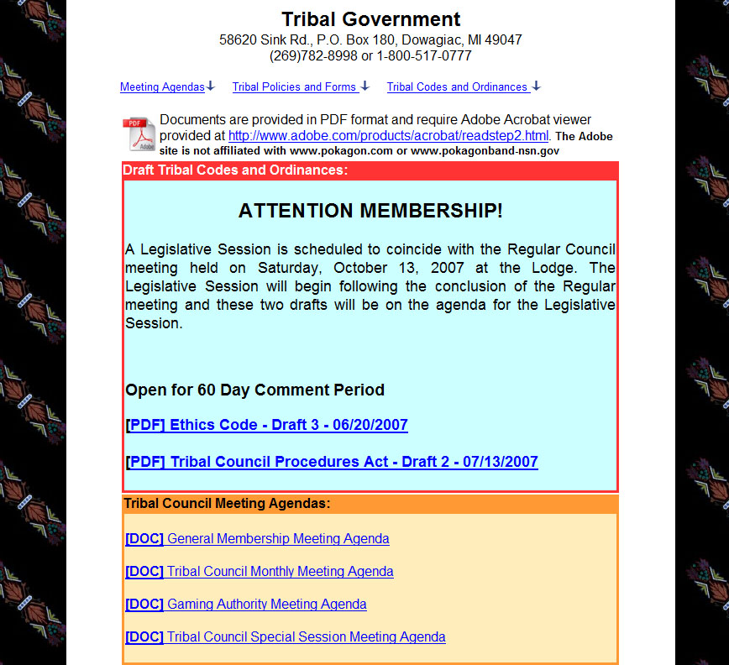

Tribal Government (Figure 1) Tribal Court (Figure 2)

General Members. The task analysis indicated that general members view objects (web material) on the web site that were posted by Tribal Council/Administration. These views are the following pages: Department of Education, Department of Human Resources, Department of Social Services, Tribal Government, Gaming Commission, and Tribal Police. Screen shots of two of these views can be seen in Figure 3 and Figure 4.

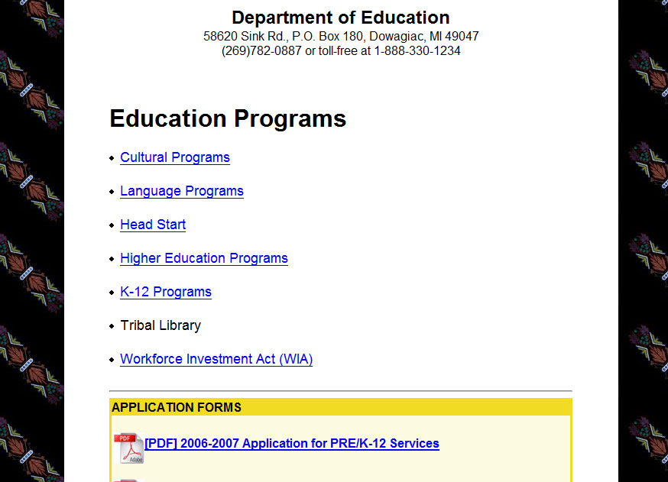
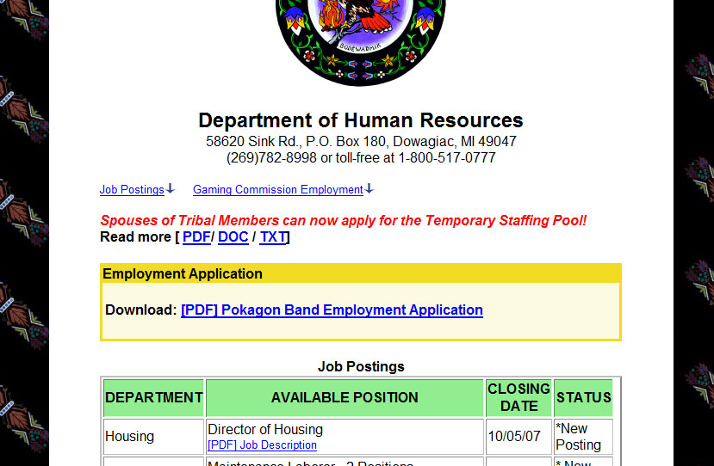

Department of Education (Figure 3) Department of Human Resources (Figure 4)

Other Potawatomi Bands of Native Americans. The task analysis indicated that other Potawatomi bands of Native Americans view the web site to compare objects (web material) to their own tribal objects. They may use them for inspiration for a revision or evidence to support a proposal. These views include the following pages: Department of Education, Department of Human Resources, Department of Social Services, Tribal Government, Gaming Commission, and Tribal Police. Two screen shots of these views can be seen in Figure 5 and Figure 6.

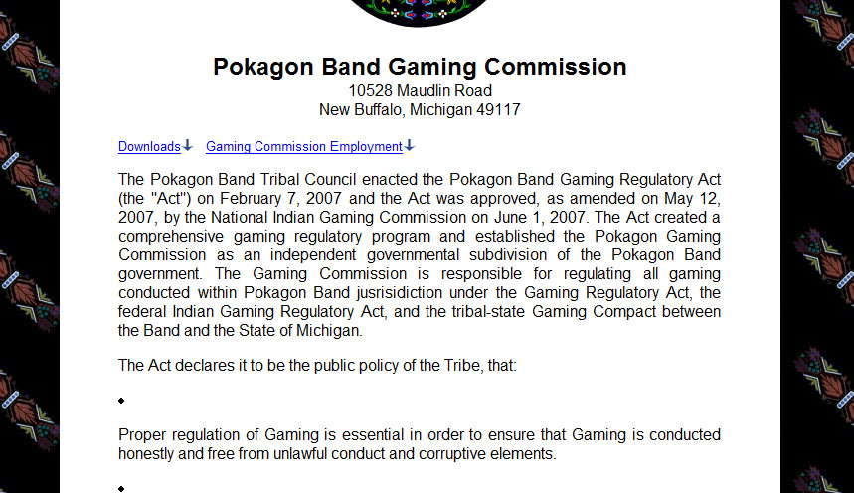
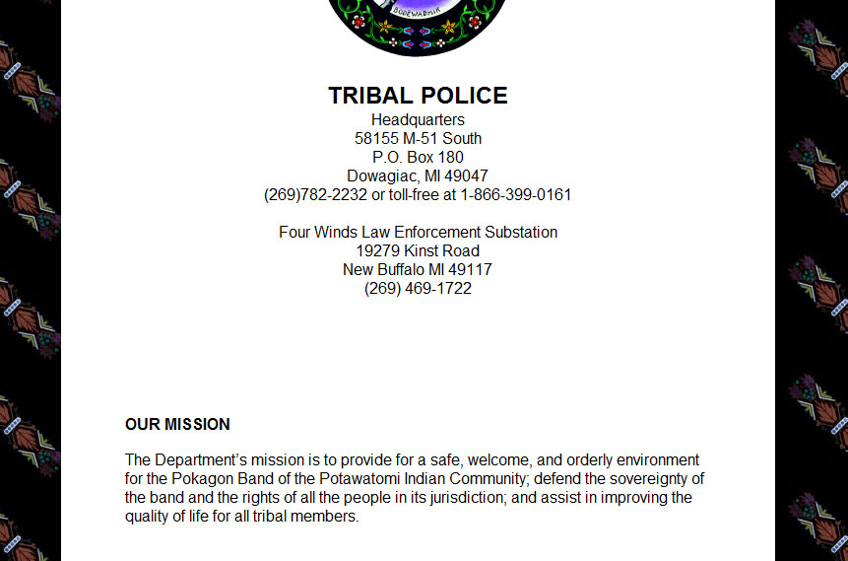

Gaming Commission (Figure 5) Tribal Police (Figure 6)

General Public (Non-Native Americans). The task analysis indicated that general public views the Pokagon Band web site to gain information about the web site. They may look through the above mentioned pages, but those pages are directed toward other user groups. The home page and links page is directed toward the general public, but the homepage (Figure 7) is not detailed enough to satisfy the interests of the general public. This view is missing from the web site.

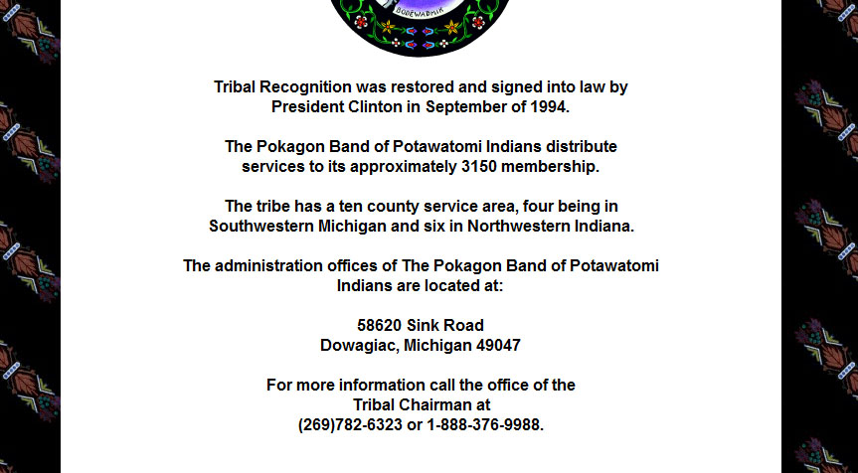

Homepage (Figure 7)

Objects
In addition to analyzing the views each user group utilizes on the Pokagon Band web site, the objects primary user by each group were also analyzed. The results from this analysis concluded that the majority of the objects on the Pokagon Band web site are PDF files and Microsoft Word files (.doc). These are available for use by the two primary user groups and the sub-user groups under each primary user groups. Information is also available to the all of these user groups in the form of web documents, through links. PDF and Word files can be found on the Department of Education, Department of Human Resources, Tribal Government, Gaming Commission, Tribal Police, and Announcements pages. Linked objected information can be found specifically on the Department of Social Services page, but most pages have some time of linked information.

